**Date:** 28.04.2019

**Attendees:** Furkan Karakaya, Mesut Uğur

**Location:** Electrical Machines Laboratory

**Target:** V1.3 Gate Driver Board (#1)

**Test type:** Inverter test with RL load

**Aims before the test:**

**1.** Current measurement with shunt resistors, harmonic content, efficiency

**Conditions:** 22 Ohm Ron, 2 Ohm Roff. 0-300V VDC. RL Load: Five different stages. 10kHz-40kHz fsw. 0.9 power factor. Sinusoidal PWM with 0.9 modulation index.

**Steps:**

1. The

**Results:**

|  |  |  |  |
| --- | --- | --- | --- |
| a1 | 5.442 A | scale1 | 2.001838 |
| a2 | 5.452 A | scale3 | 2.011222 |
| a3 | 5.436 A |  |  |
| a4 | 5.497 A |  |  |

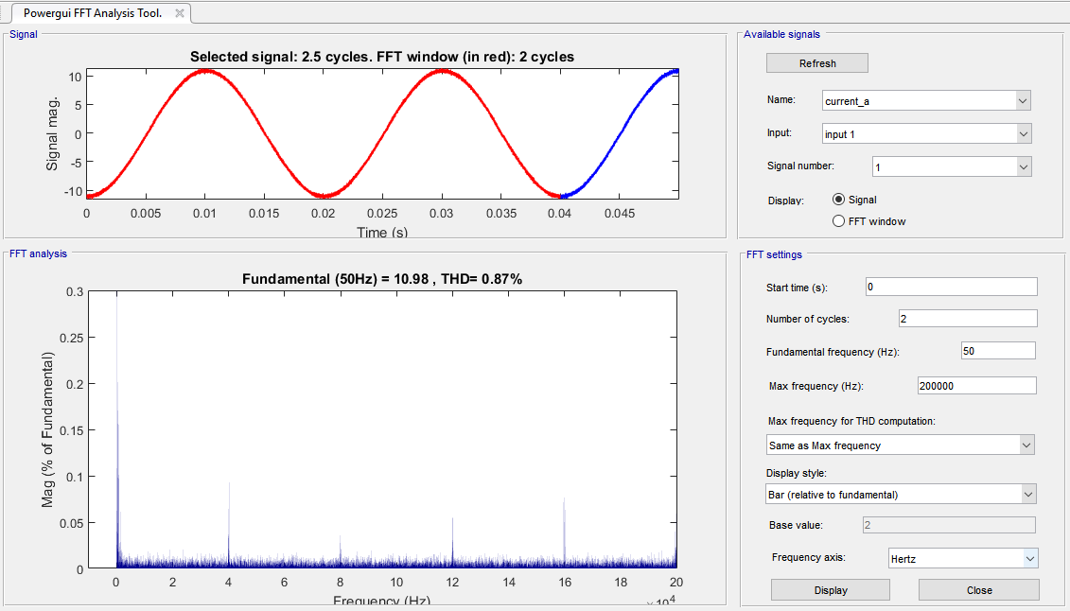

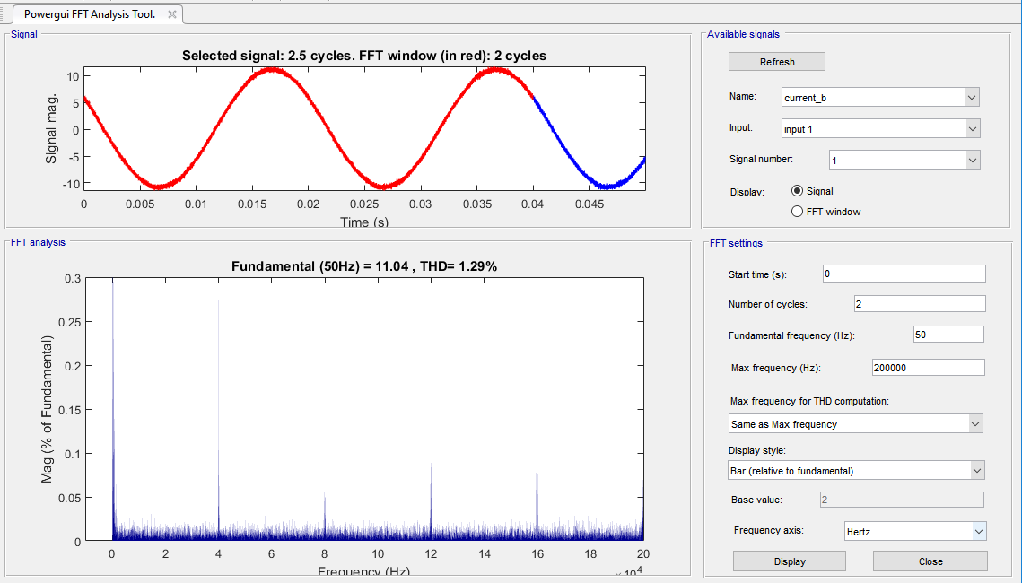

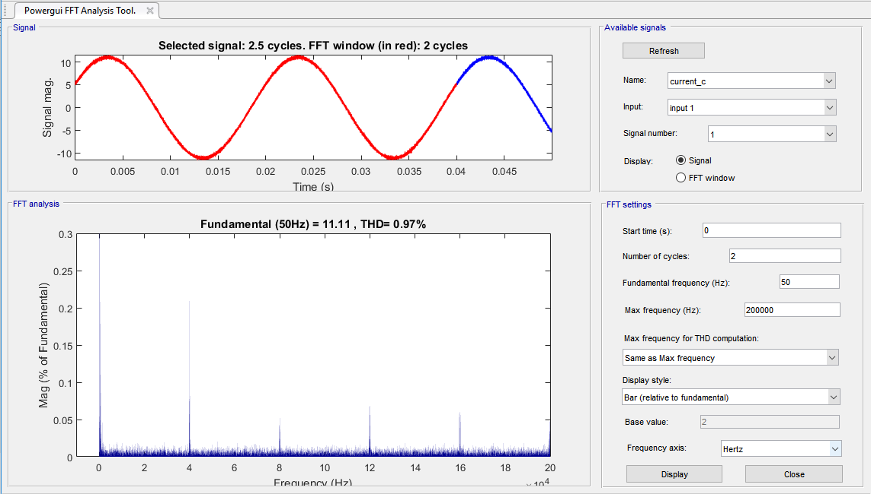

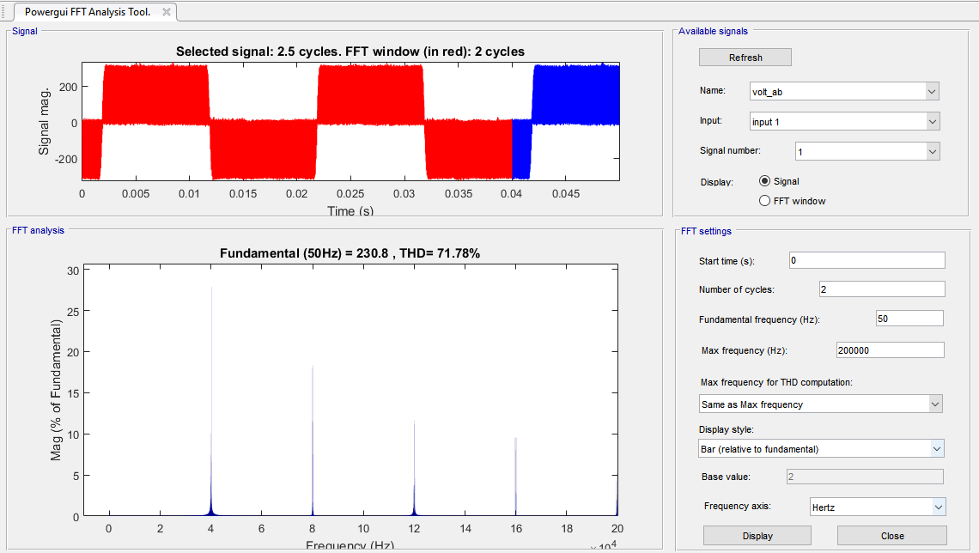

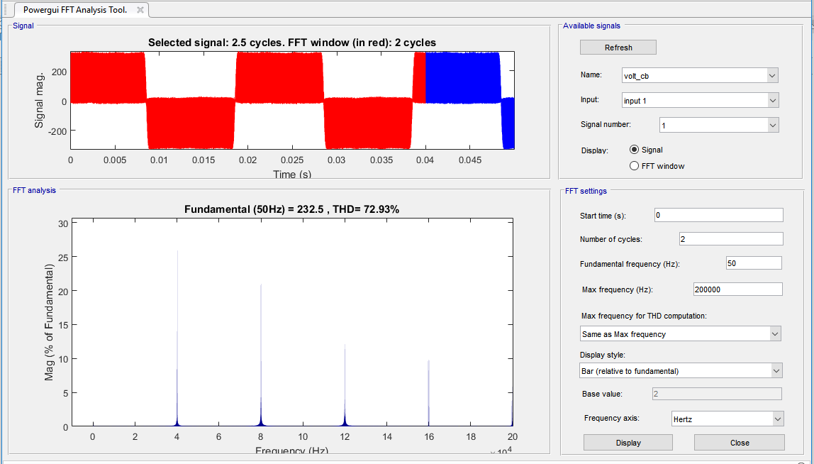

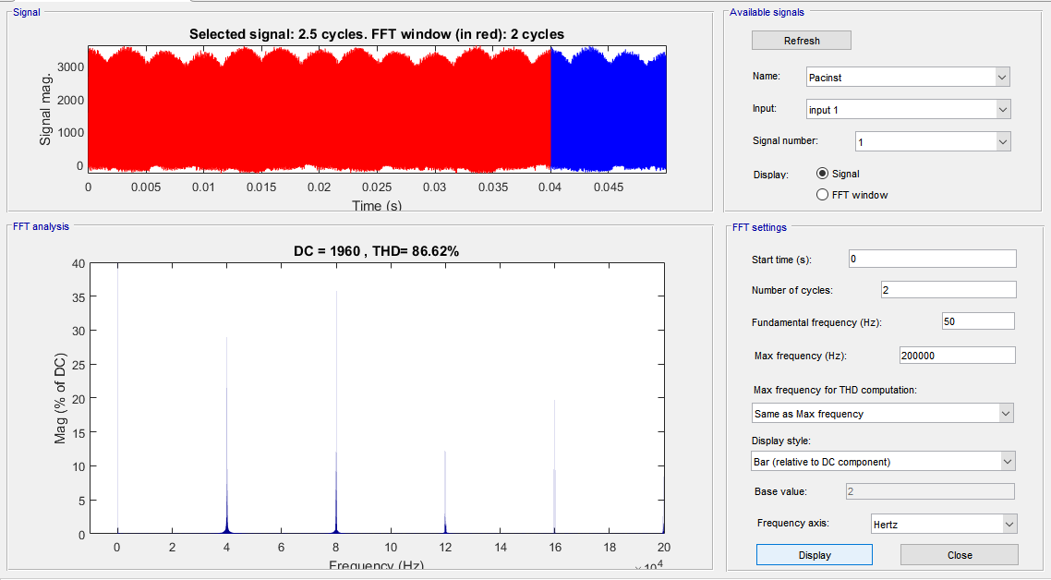

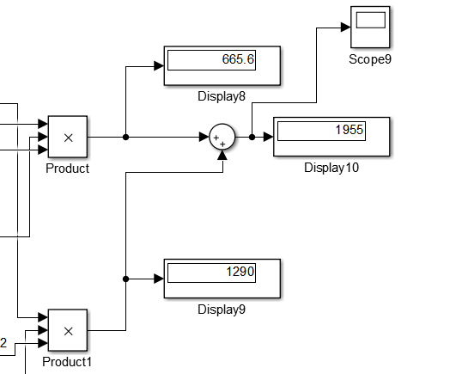

**DC:**

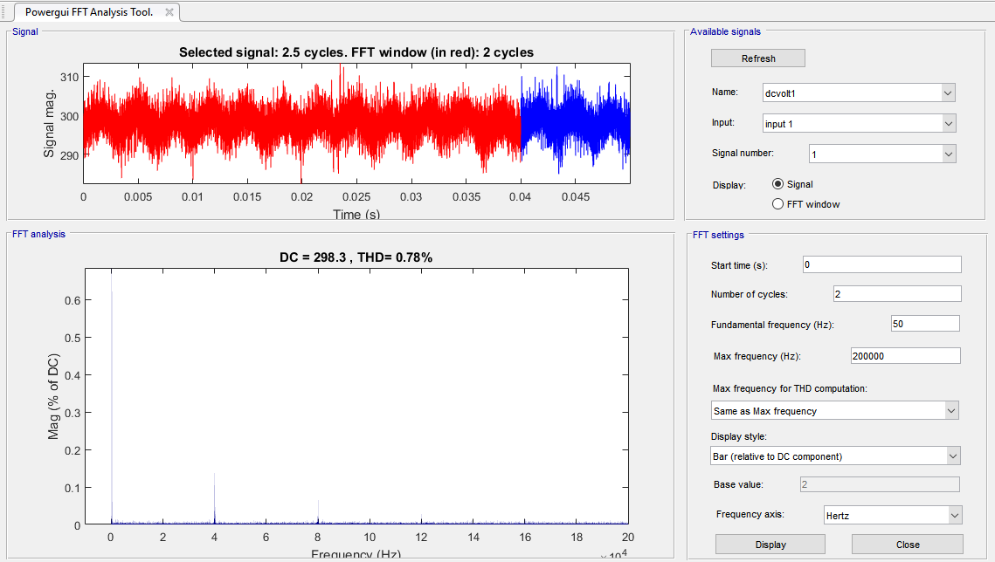

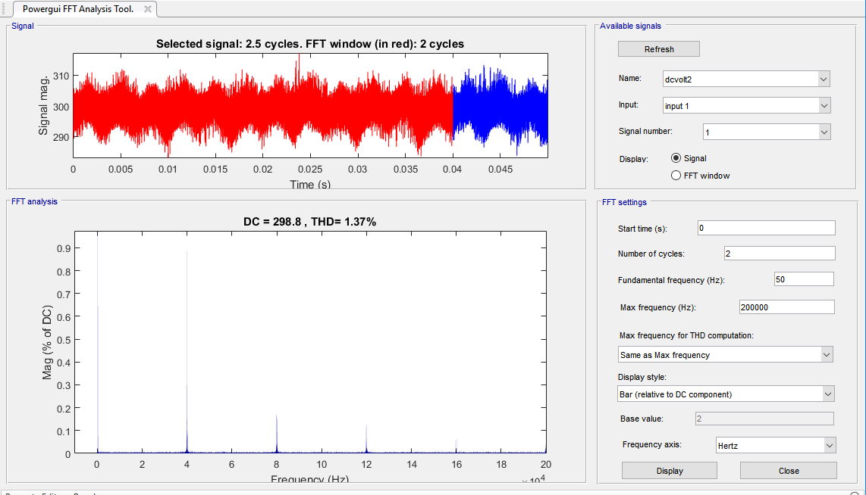

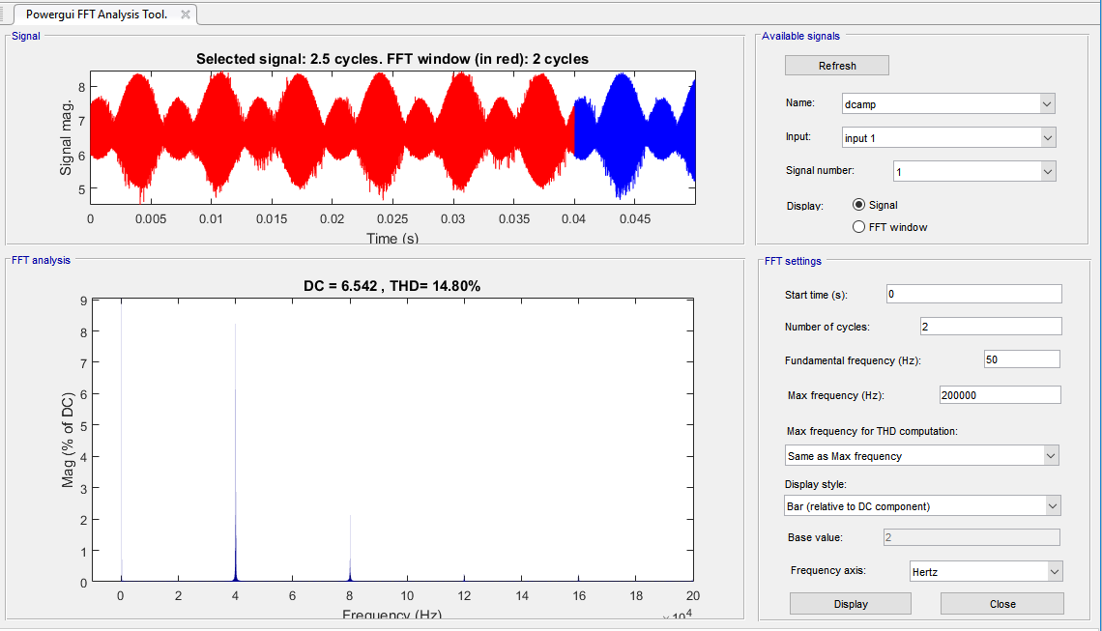

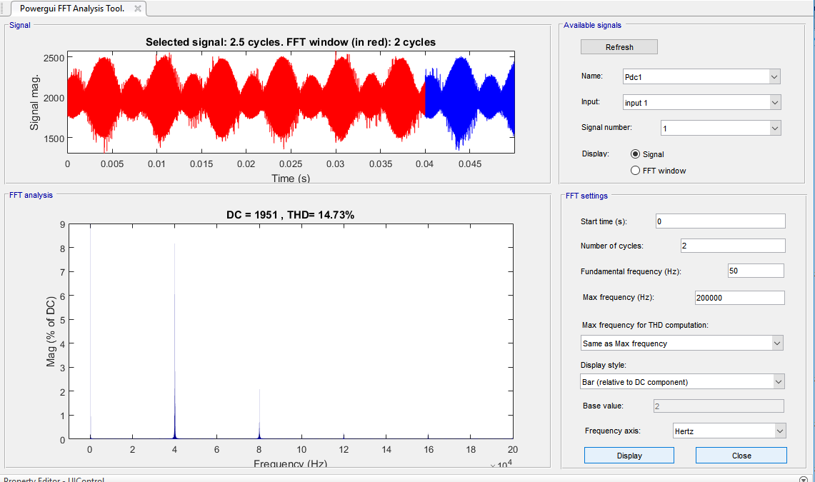

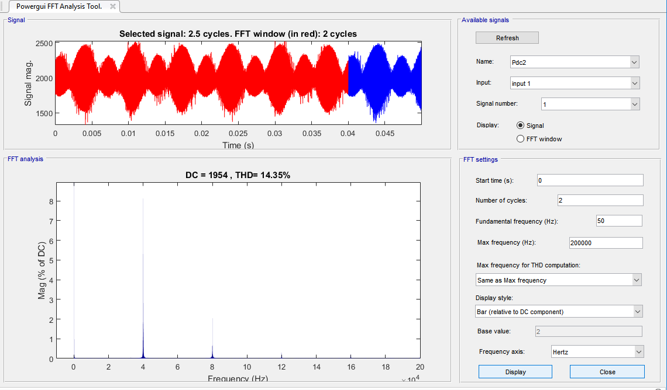

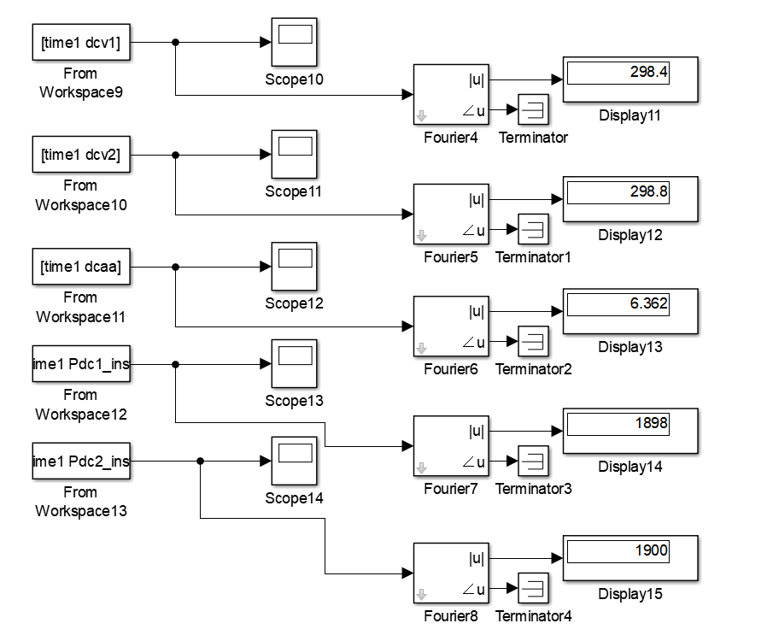

**From DC:**

**scale31 =**

**1.99394266368549**

**scale32 =**

**1.99431560238476**

**scale41 =**

**2.00609425124384**

**scale42 =**

**2.00586901869257**

**From AC:**

**scale12 =**

**2.01731540901416**

**scale22 =**

**1.98345121201965**

**scale32 =**

**2.01131024311374**

**scale42 =**

**1.98933046964858**

